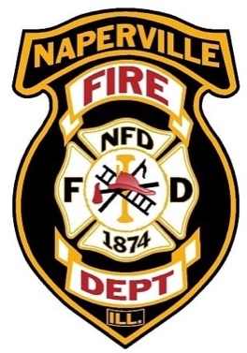
NAPERVILLE FIRE DEPARTMENT
INTER-DEPARTMENT MEMORANDUM

Date: December 2, 2024
To: Naperville Foreign Fire Insurance Board
From: Andy Bartik, Board Secretary
Subject: Agenda for the December 5, 2024 FFIB regular meeting at
8:00 a.m. Naperville Fire Department conference room.

- CALL TO ORDER

- ROLL CALL

- OPEN/PUBLIC FORUM

- APPROVAL OF MINUTES

- TREASURER’S REPORT

- BOARD ADMINISTRATIVE UPDATE

  - General information
  - Service recognition
  - Compliance officer
  - Reimbursement program
    - Discuss updating flashlight list from A. Hilk
    - Discuss probationary eligibility
  - Wellness/Fitness Program
  - Elections

- Fire Department Administrative Update

- Old Business

  - Poseidon nozzle – Jost
  - Cadet SCBA masks – Garon
  - Building comprehension class – Sergeant
  - Medic TIC’s – Bolda

- New Business

  - Rollerbags -J. Stiegler

- Adjournment

Cc: Lt. Chuck Gros – Chairman
FPM Andy Bartik – Secretary
FPM Matt Randall – Treasurer
FPM Chuck Smith – Board Member
FPM Daryl MacDonald – Board Member
FPM Jim Streu – Board Member
Chief Puknaitis – Board Member
Naperville Fire Department Sharepoint
Naperville Fire Protection Board
City of Naperville website

Special Accommodation: Any individual with a disability requiring a reasonable accommodation in order to participate in a meeting should contact the Division of Social Services 630/420-6001 (voice) 630/305-5205 (TDD) or the City Clerk’s office 630/305- 5300, to coordinate ADA services. Please contact the City at least five working days in advance of the next scheduled meeting.

